Level 6 -> Level 7

The goal of this level is to find out the file somewhere on the server, which is owned by user bandit7, owned by group banit6, 33 bytes in size and get the password of next level.

Here, **find** command will be very used for us. **find** command is used to search and locate the list of files and directories based on conditions we specify for files that match the arguments. It can be used in a variety of conditions like we can find files by **permissions**, u**sers**, **groups**, **file type**, **date**, **size**, and other possible criteria.

Here in this level we are provided with user name, group and size so, we can use command **find / -user bandit7 -group bandit6 -size 33c**

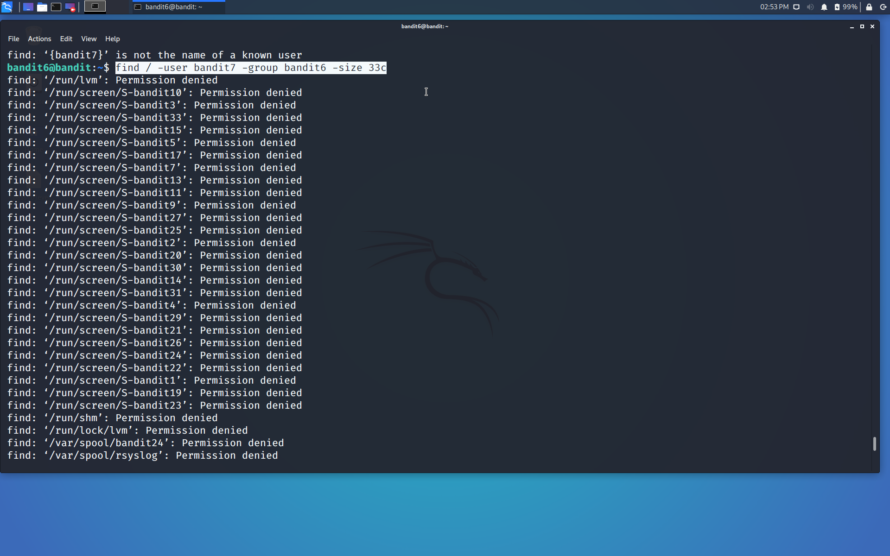

Found the location of the required file: **/var/lib/dpkg/info/** and the file name is **bandit7.password**

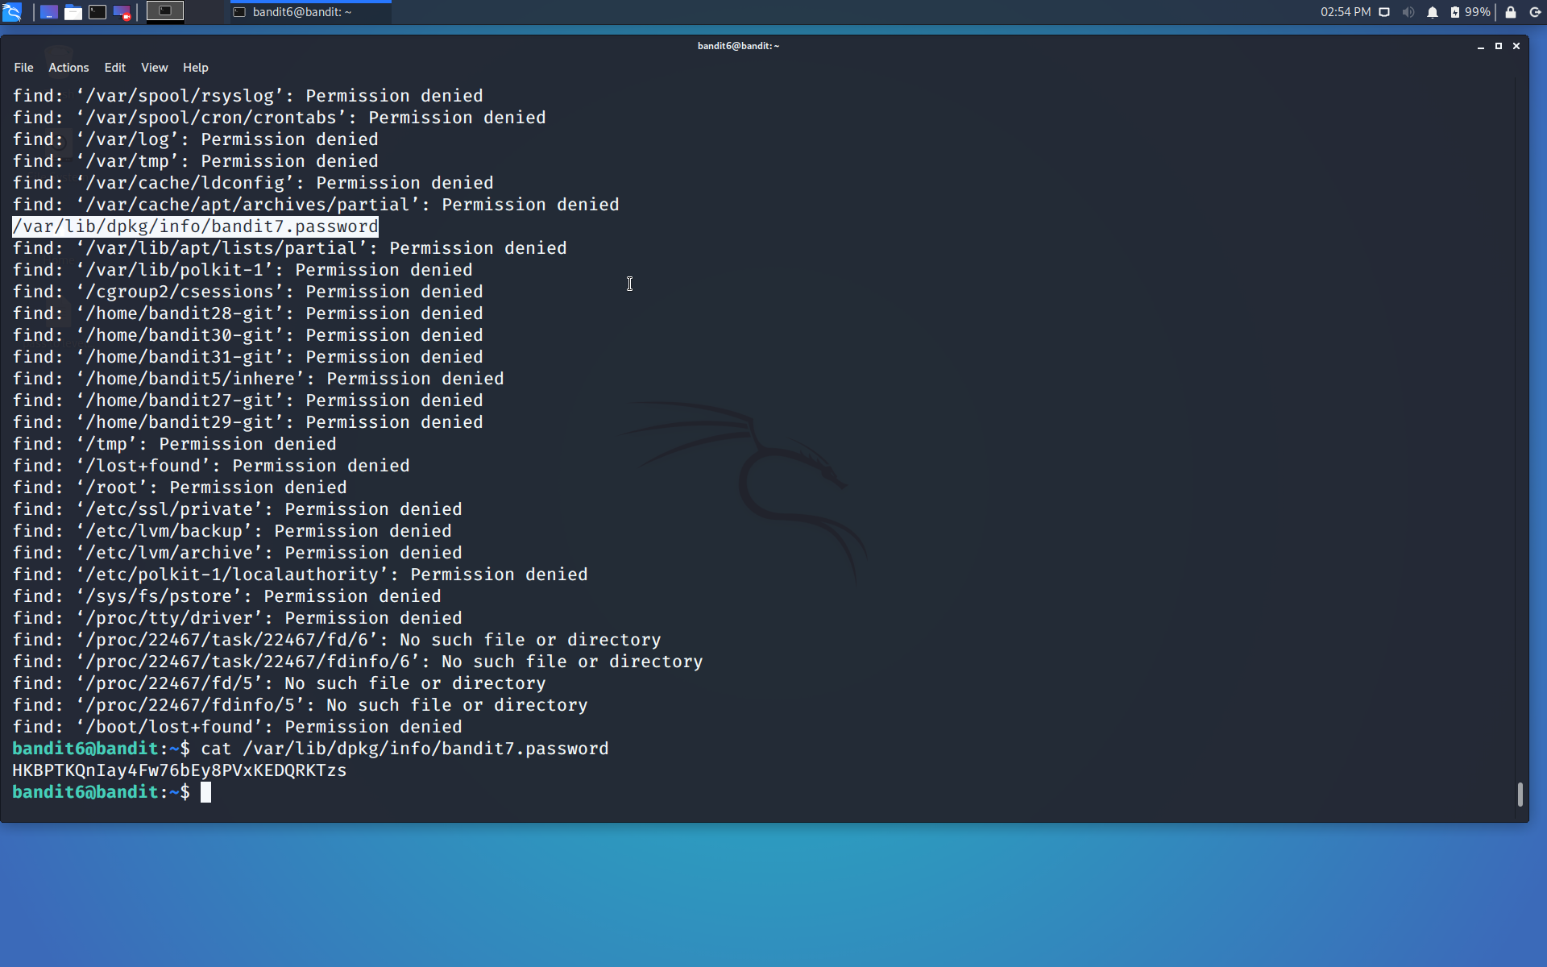

Using cat command we will read the content of the fill i.e. the password.

We got the password…

Use the command **ssh bandit7@localhost** to connect to the level 7.

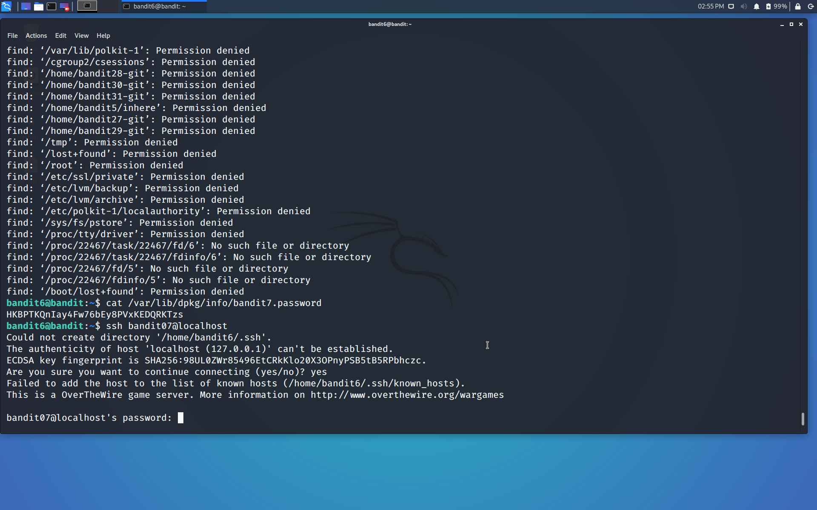

Enter the password and hit enter.

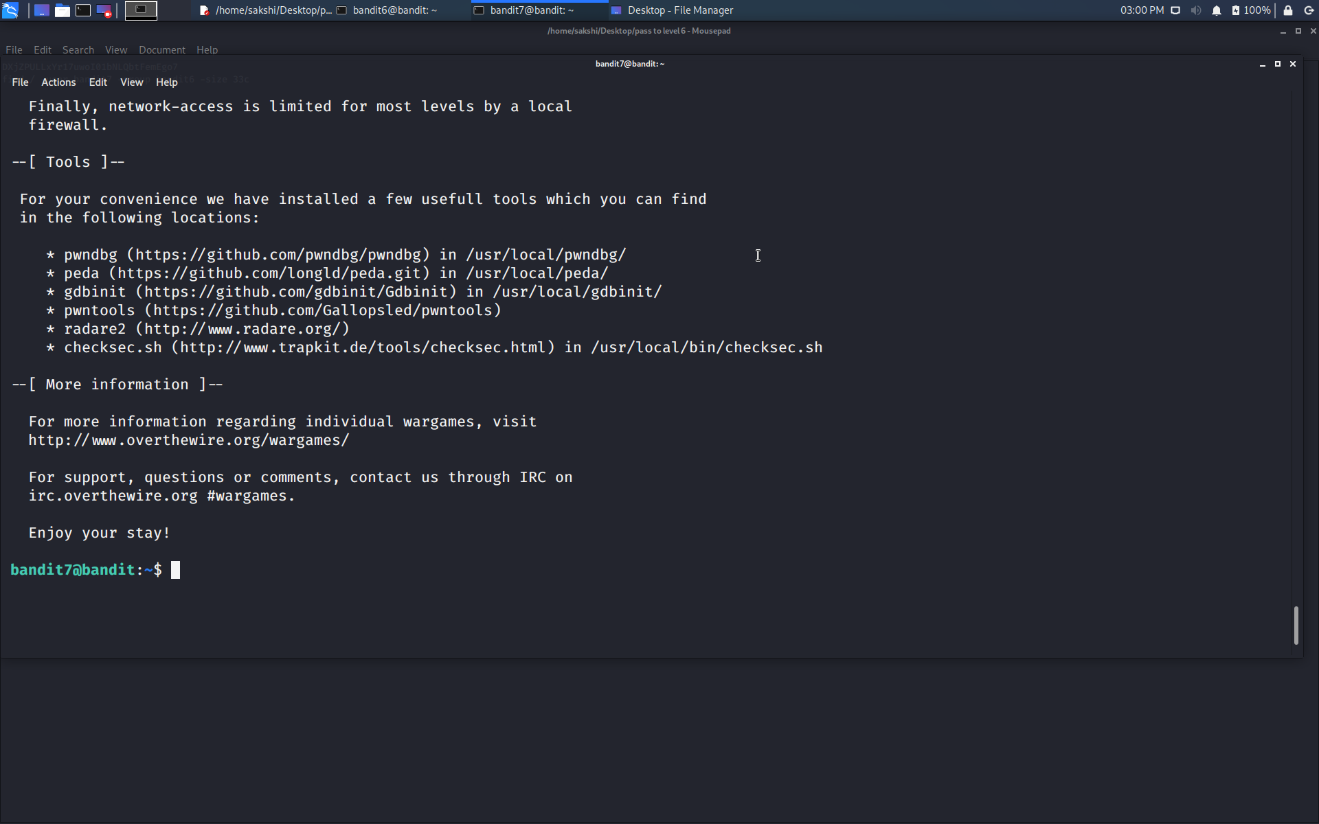

Successfully passed level 7.…